**LOAD**

Loads data from the file system.

Syntax

LOAD 'data' [USING function] [AS schema];

Suppose we have a data file called emp.

The fields are tab-delimited.

The records are comma separated.

101,swathi,30000  
102,rahila,33000  
103,malar,32000  
104,swathi,36000  
105,rahila,35000  
106,nila,20000  
107,kalai,25000

In this example the default load function, PigStorage, loads data from emp to form relation employee_details.

The two LOAD statements are equivalent.

Note that, because no schema is specified, the fields are not named and all fields default to type bytearray.

Employee_details= LOAD '/user/acadgild/emp';

Employee_details= LOAD '/user/acadgild/emp' USING PigStorage(',') ;

In below example, the data is given with specified datatype.

Employee_details= LOAD '/user/acadgild/emp' USING PigStorage(',') as (emp_id:int,emp_name:chararray,emp_salary:int) ;

DUMP employee_details;

(101,swathi,30000)  
(102,rahila,33000)  
(103,malar,32000)  
(104,swathi,36000)  
(105,rahila,35000)  
(106,nila,20000)  
(107,kalai,25000)

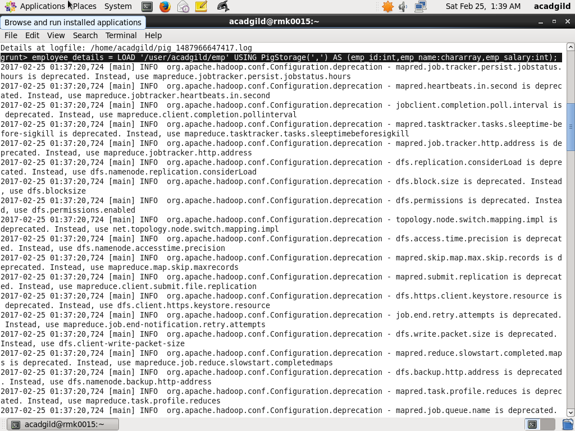

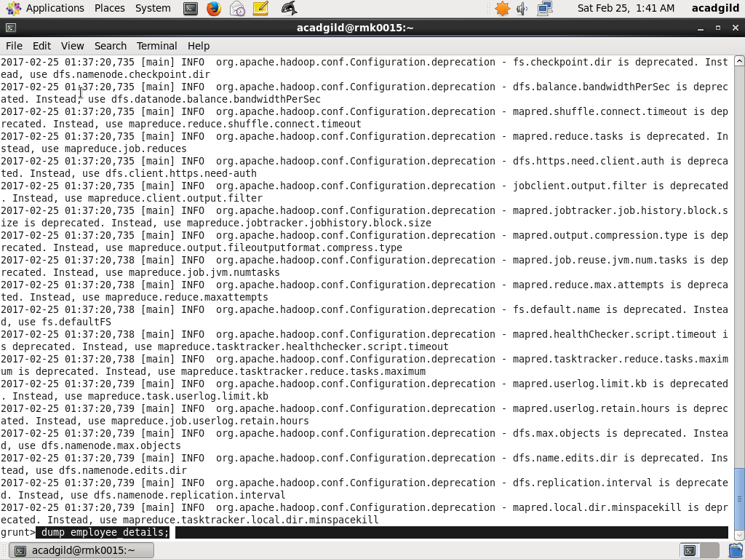

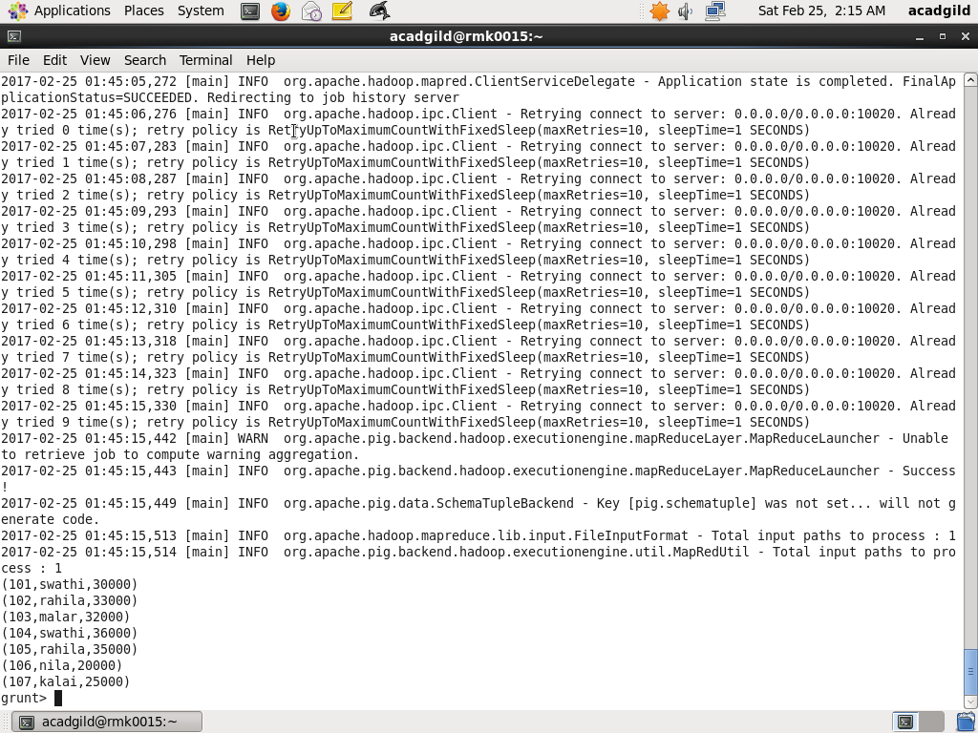

**STORE**

Stores or saves results to the file system.

**Syntax**

STORE alias INTO 'directory' [USING function];

Employee_details= LOAD '/user/acadgild/emp' USING PigStorage(',') as (emp_id:int,emp_name:chararray,emp_salary:int) ;

DUMP employee_details;

STORE employee_details INTO 'employee_details' USING PigStorage (';');

CAT employee_details;

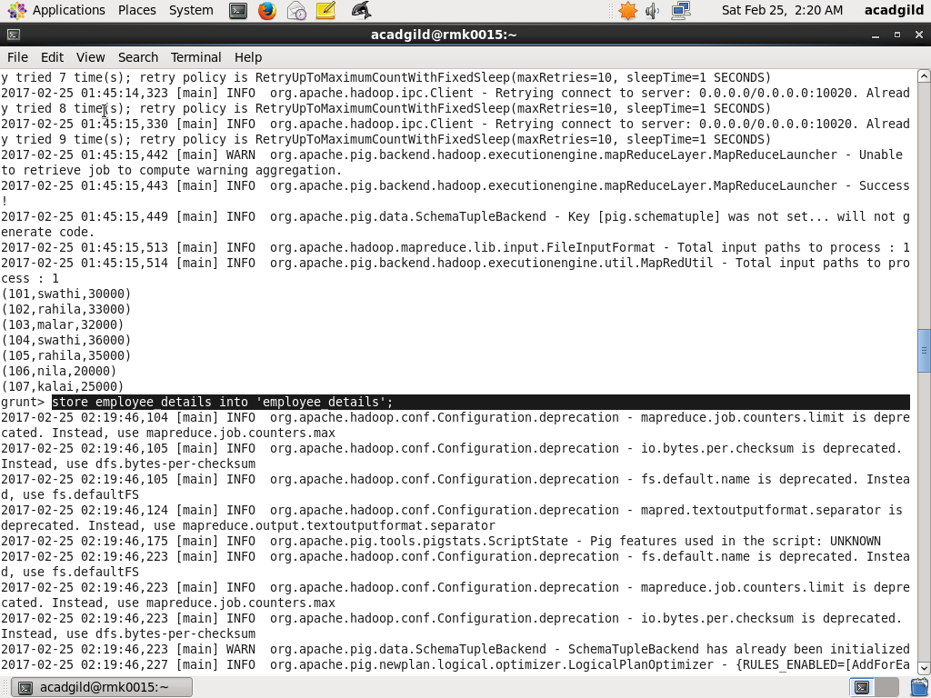

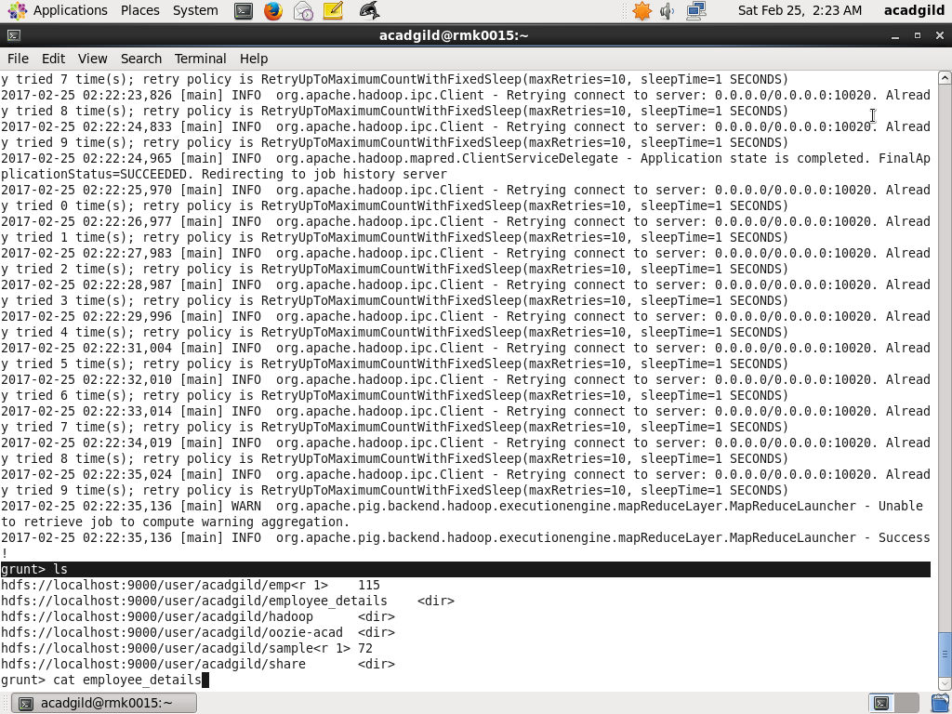

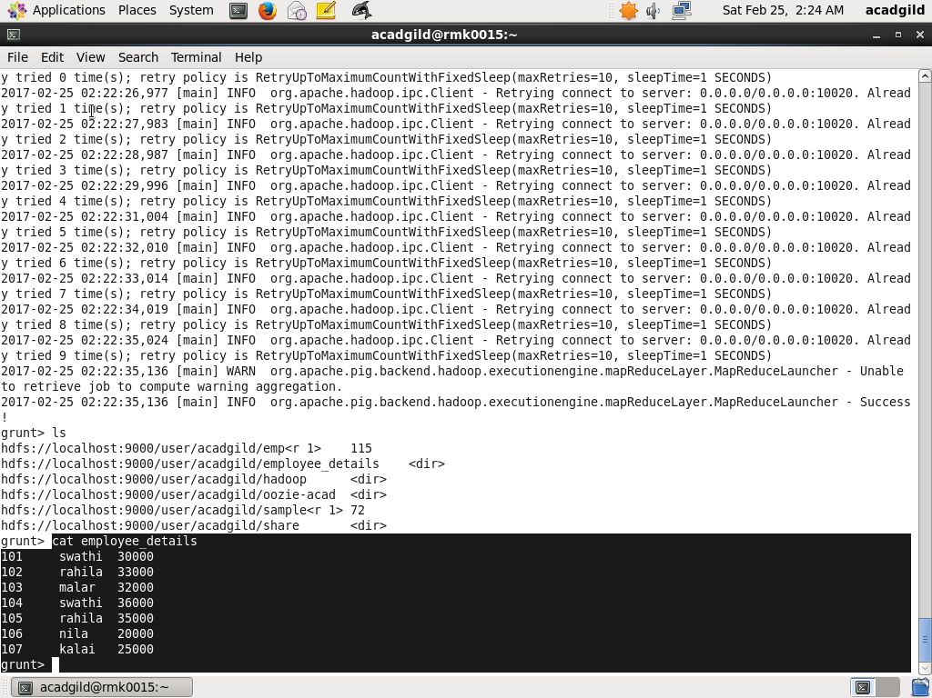

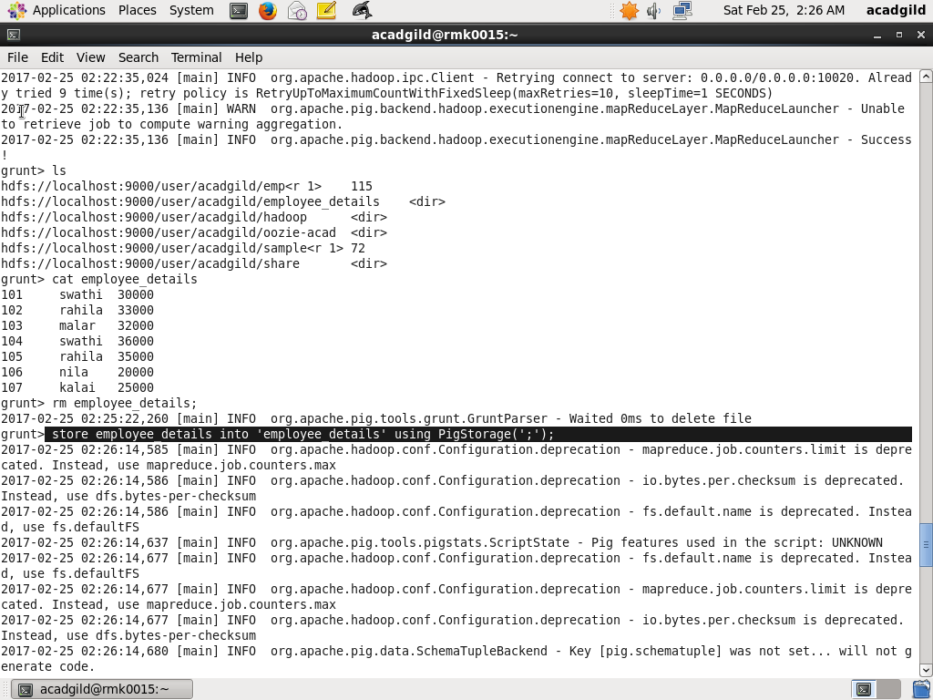

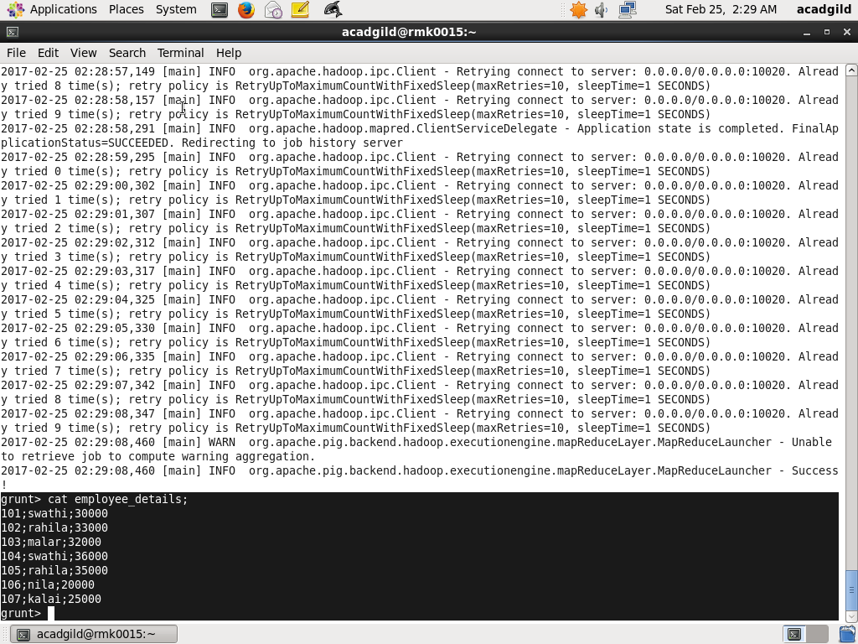

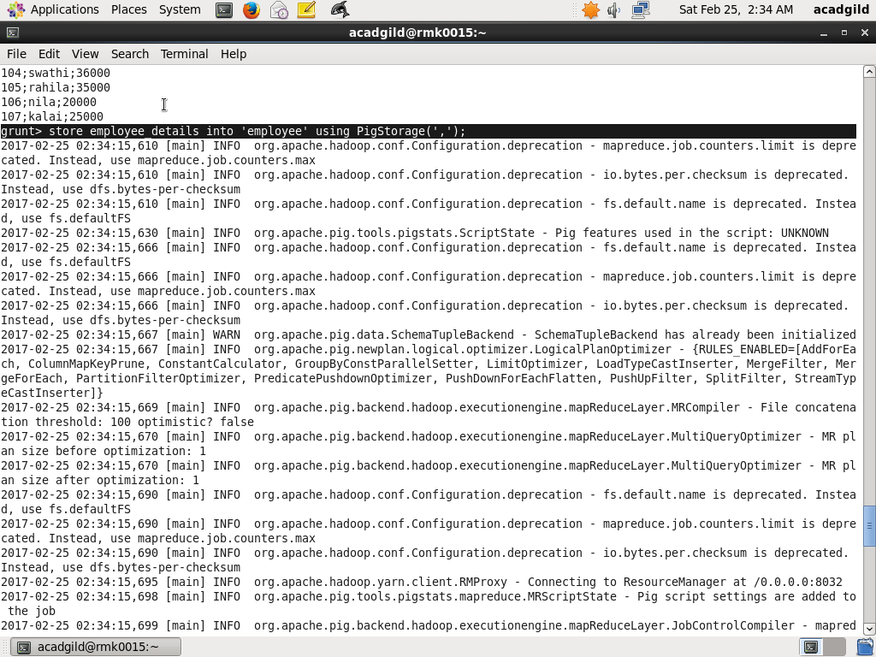

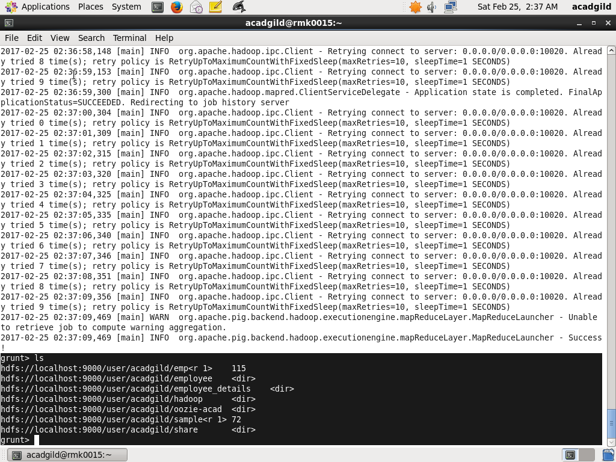

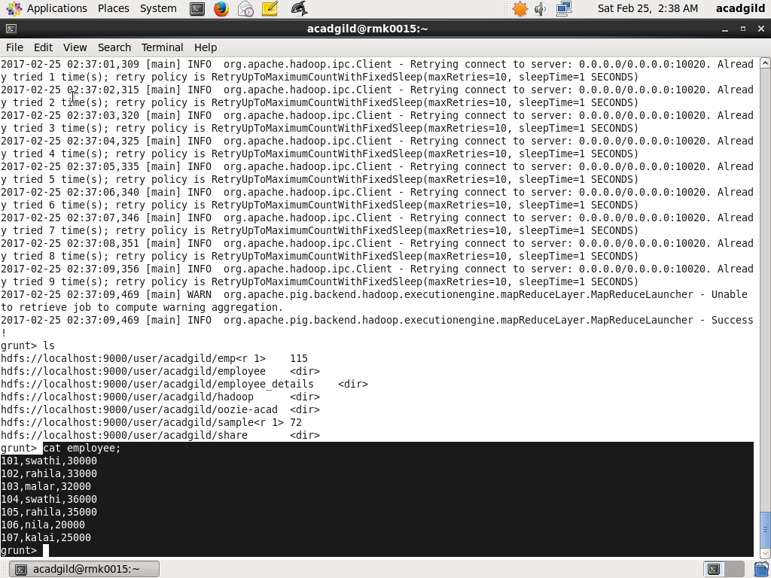

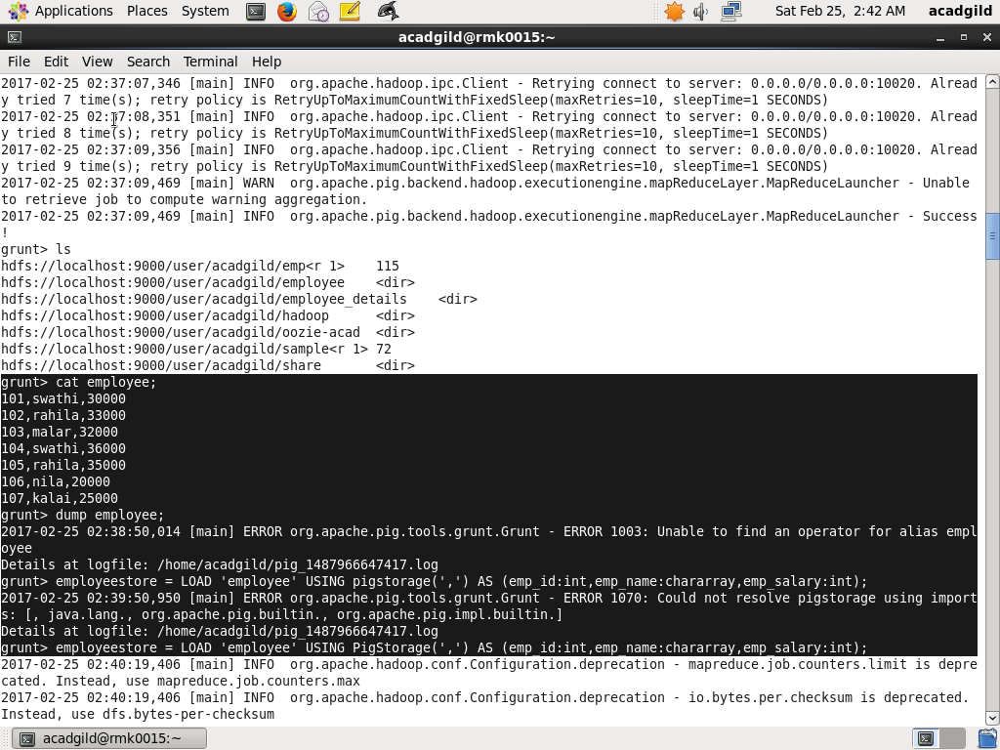

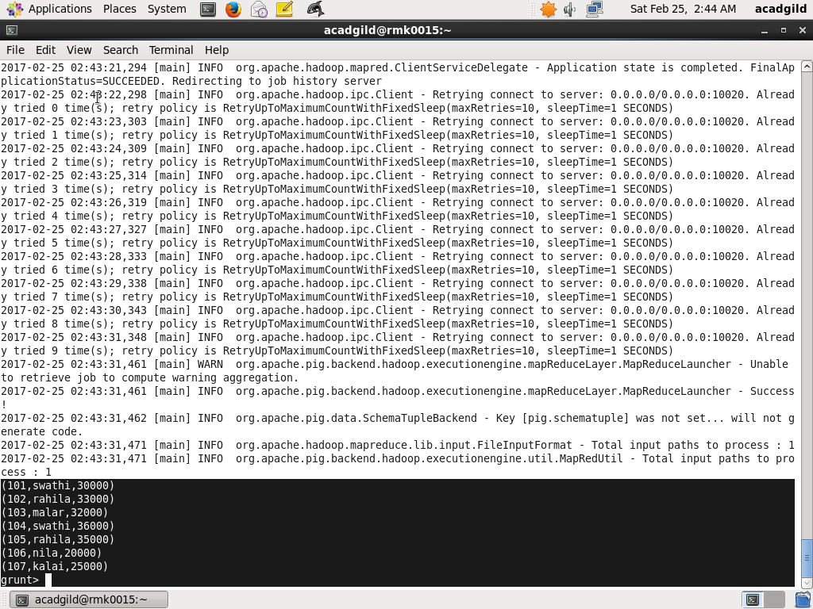

**DUMP**

Dumps or displays results to screen.

Syntax

DUMP alias;

Example:

DUMP employee_details;





**FOREACH**

Generates data transformations based on columns of data.

Syntax

alias = FOREACH generate_operations [AS schema];

Examples:

Emp_salary = FOREACH employee_details GENERATE emp_name,emp_salary*12;

Emp_salary = FOREACH employee_details GENERATE emp_name,emp_salary*12 as annual_salary;

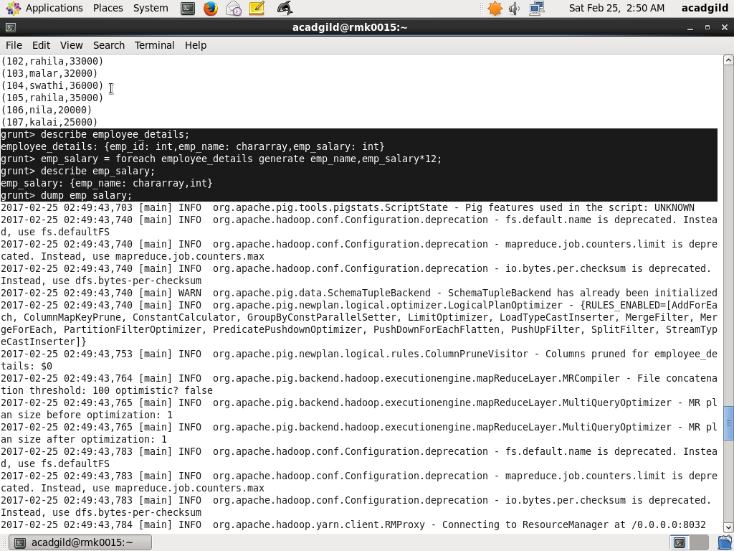

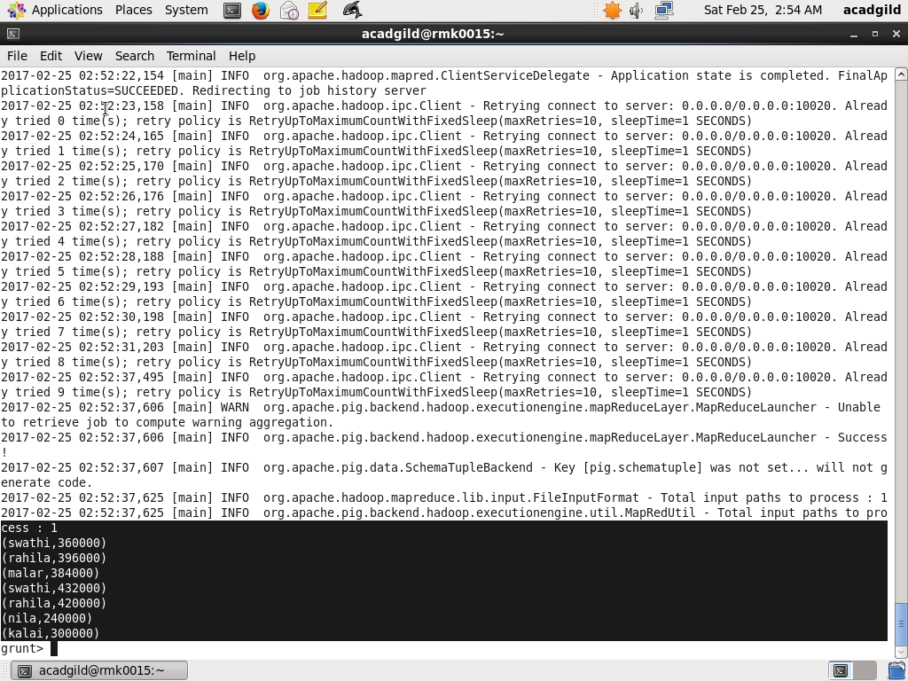

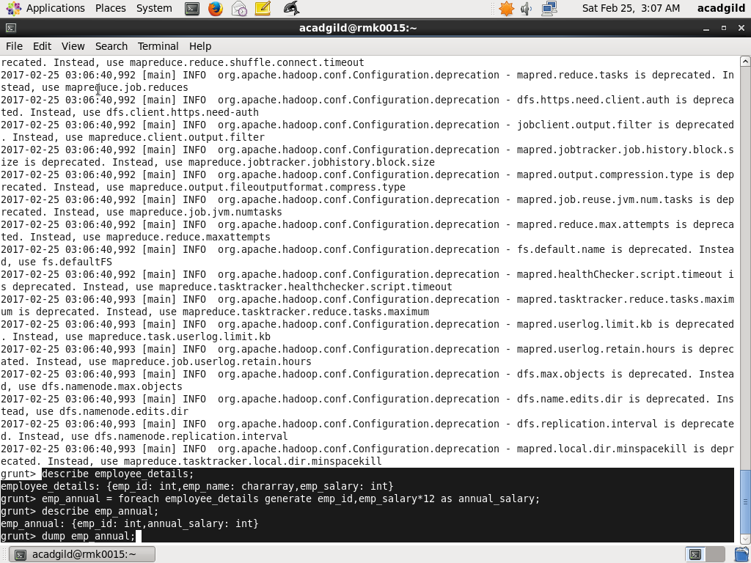

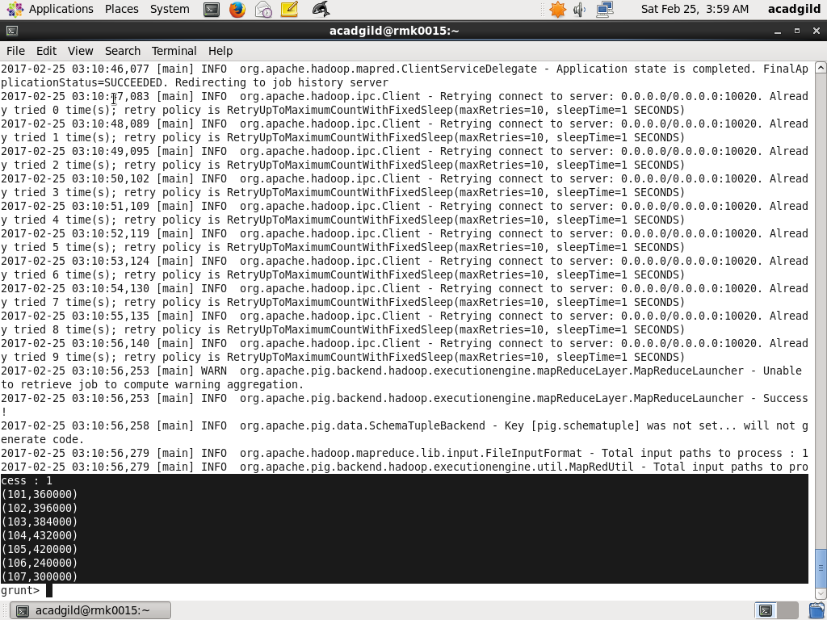

**FILTER**

Selects tuples from a relation based on some condition.

Syntax

alias = FILTER alias BY expression;

Employee_details=LOAD ‘/user/acadgild/emp’ using PigStorage(‘,’) as (emp_id:int,emp_name:chararray,emp_salary:int);

DUMP employee_details;

In this example the condition states that if the emp_id field less than 105, then include the tuple with relation filter_employee.

Filter_employee = FILTER employee_details BY emp_id<105;

DUMP filter_employee;

(101,swathi,30000)

(102,rahila,33000)

(103,malar,32000)

(104,swathi,36000)

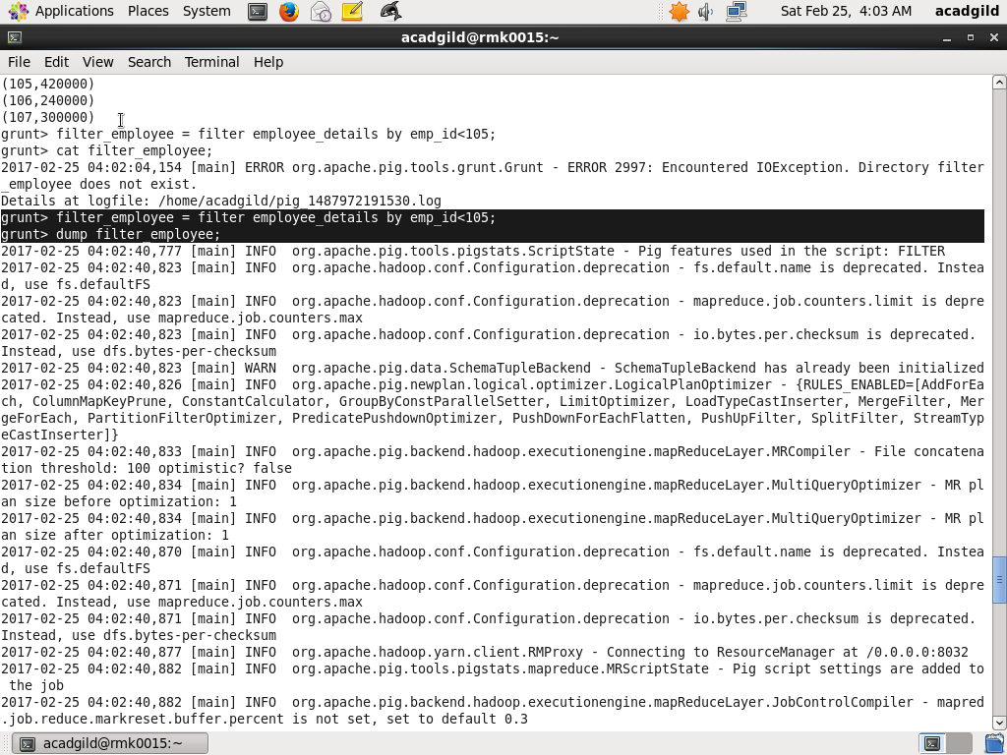

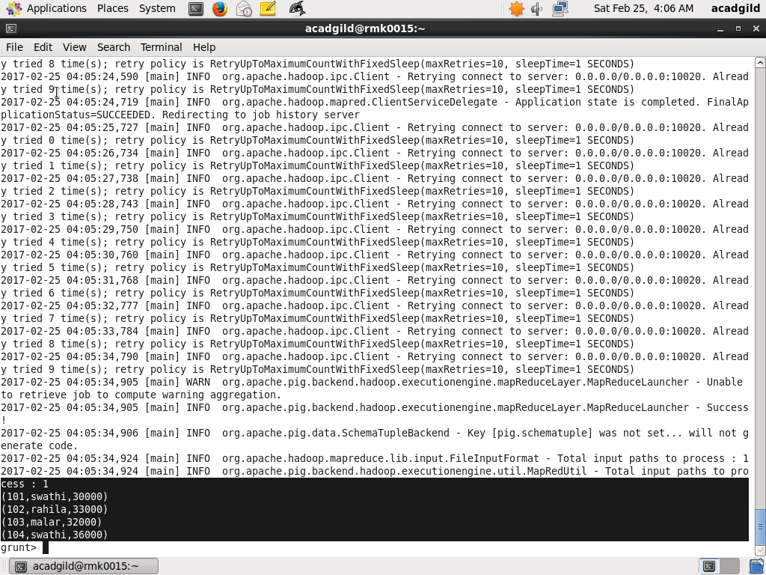

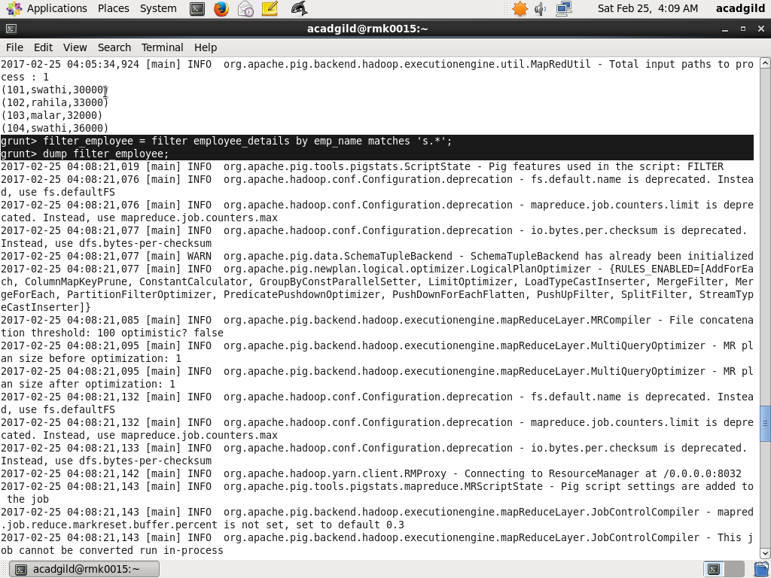

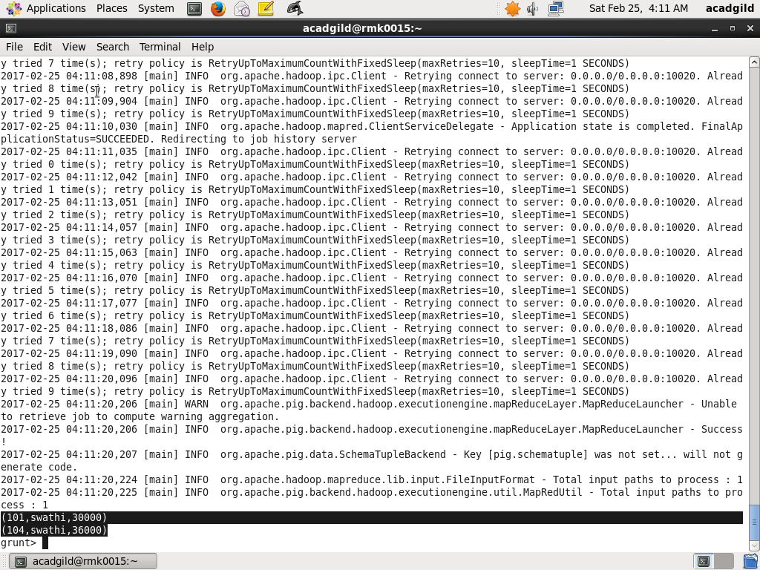

**GROUP BY**

Groups the data in one or multiple relations.

Syntax:

alias = GROUP alias { ALL | BY expression} [, alias ALL | BY expression …] [PARALLEL n];

The GROUP operator groups together tuples that have the same group key .

The key field will be a tuple if the group key has more than one field, otherwise it will be the same type as that of the group key. The result of a GROUP operation is a relation that includes one tuple per group. This tuple contains two fields:

The first field is named group and is the same type as the group key.

The second field takes the name of the original relation and is type bag.

The names of both fields are generated by the system.

Employee_details= load '/user/acadgild/emp' AS (emp_id:int,emp_name:chararray,emp_salary:int);

DESCRIBE employee_details;

Employee_details: {emp_id:int,emp_name: chararray,emp_salary: int}

Grouping_employee= group employee_details by emp_name;

Describe grouping_employee;

Grouping_employee: {group:chararray,employee_details: {(emp_id: int,emp_name: chararray,emp_salary: int)}

DUMP grouping_employee;

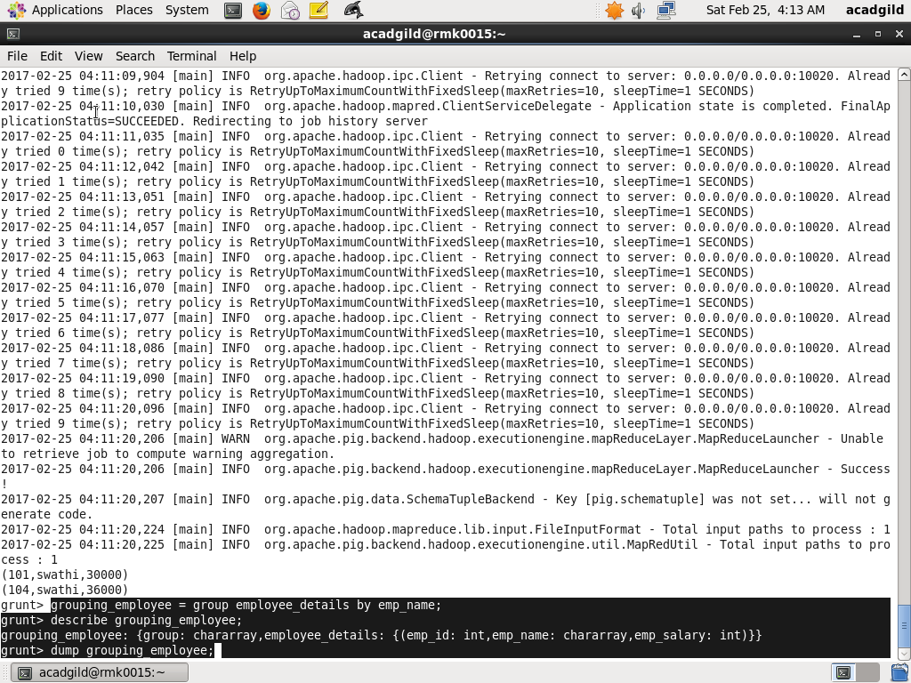

(nila,{(106,nila,20000)})

(kalai,{(107,kalai,25000)})

(malar,{(103,malar,32000)})

(rahila,{(105,rahila,35000),(102,rahila,33000)})

(swathi,{(104,swathi,36000),(101,swathi,30000)})

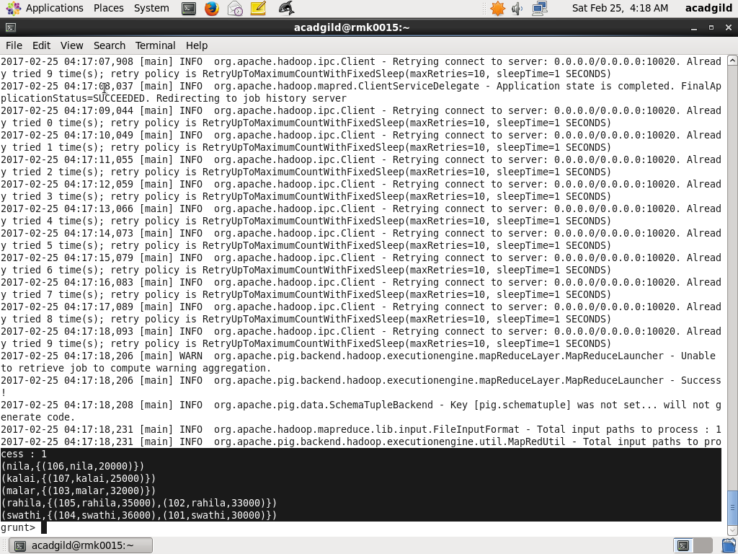

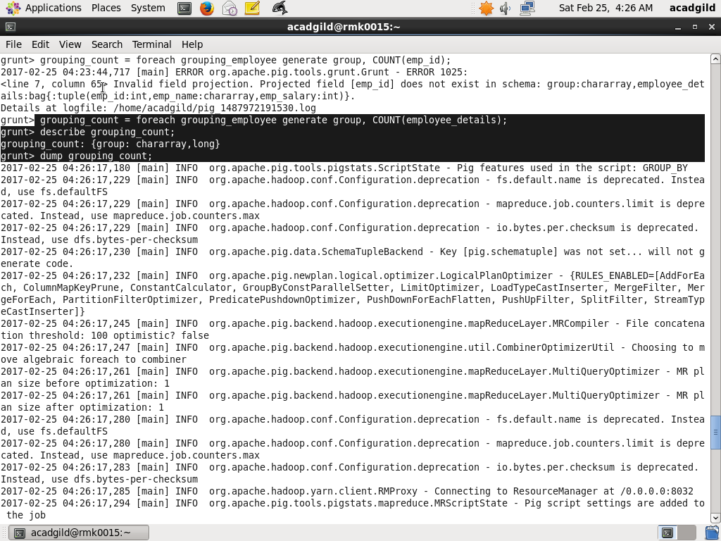

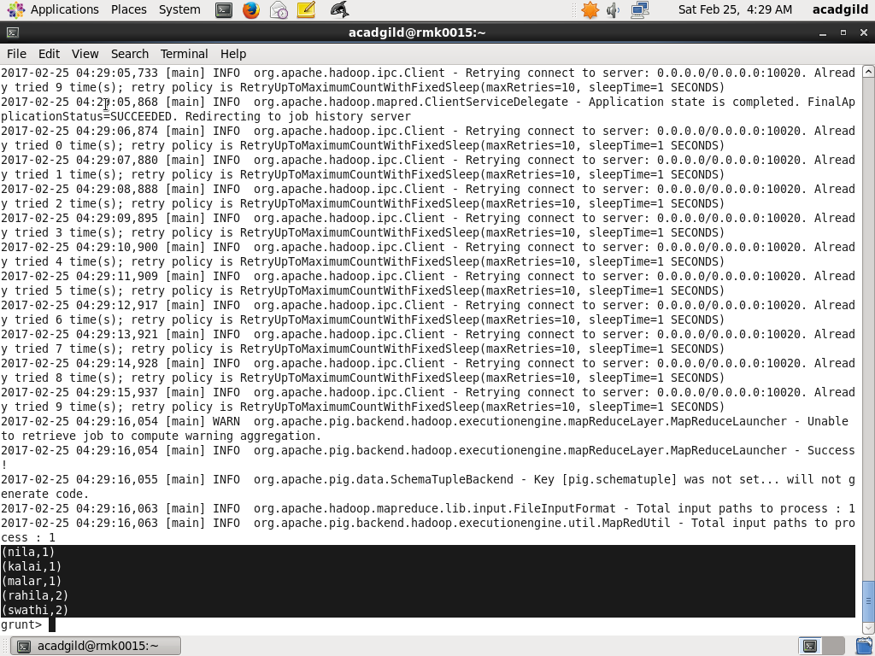

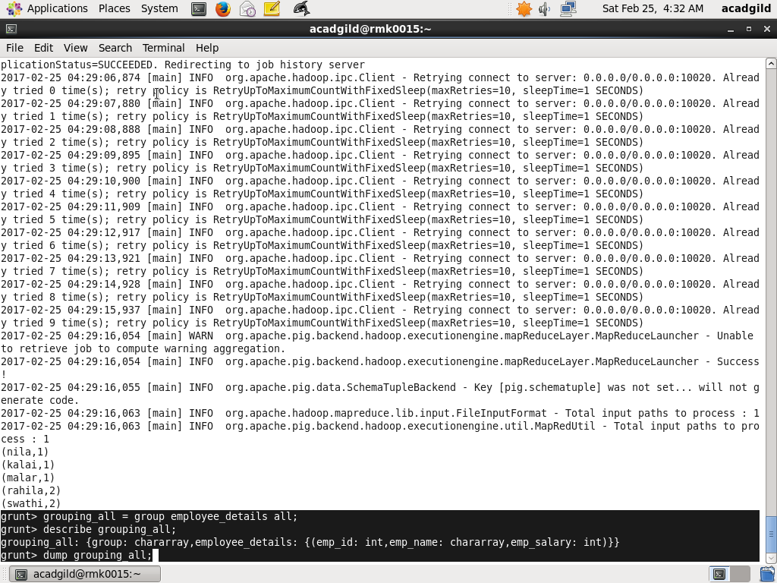

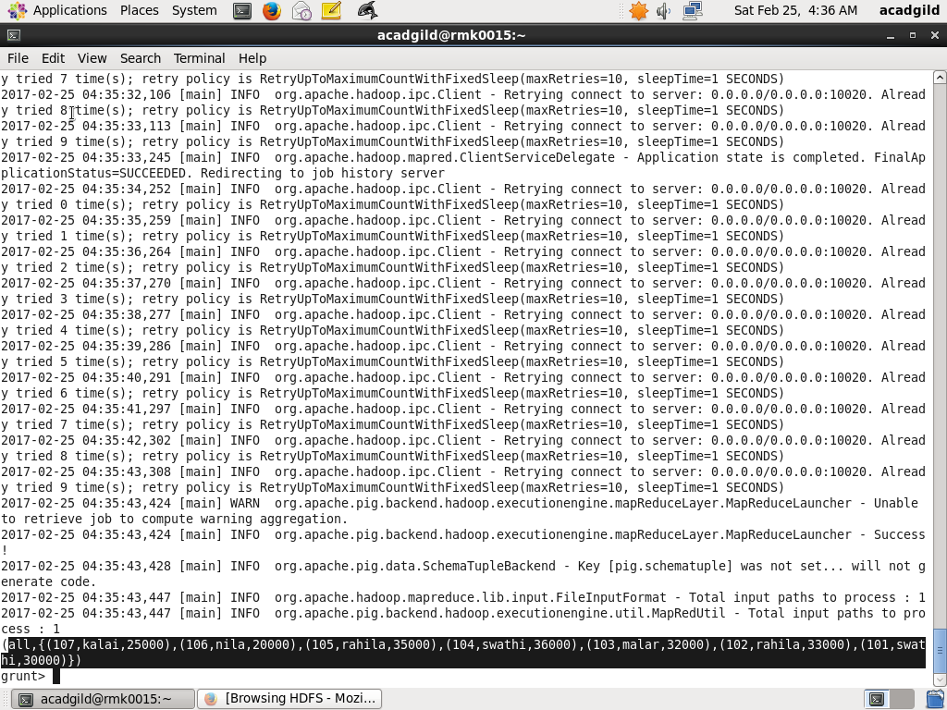

**ORDER BY**

Sorts a relation based on one or more fields.

Syntax

alias = ORDER alias BY { * [ASC|DESC] | field_alias [ASC|DESC] [, field_alias [ASC|DESC] …] } [PARALLEL n]; Terms alias

The name of a relation.

ASC

Sort in ascending order.

DESC

Sort in descending order.

For example,

Ordering_employee = order emp_annual by annual_salary desc;

Dump ordering_employee;

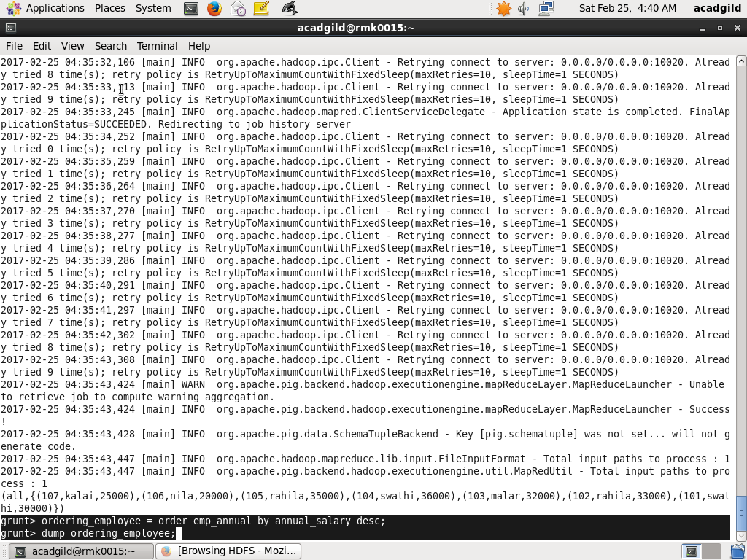

(104,432000)

(105,420000)

(102,396000)

(103,384000)

(!011,360000)

(107,300000)

(106,240000)

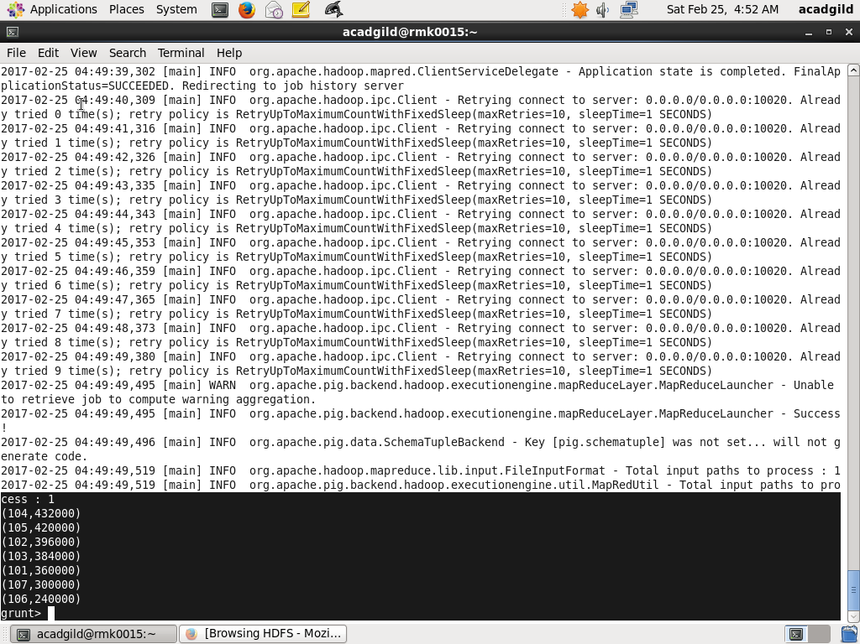

**DESCRIBE**

Returns the schema of an alias.

Syntax

DESCRIBE alias;

For example,

DESCRIBE employee_details;

